P2 重难点针对性练习题(电化学)
一.电化学 (金属作为电极), Hydrogen fuel cell
1. 了解电解的原理
1.Which statement about electrolysis is correct? （ ）
A Electrons move through the electrolyte from the cathode to the anode.
B Electrons move towards the cathode in the external circuit.
C Negative ions move towards the anode in the external circuit.
D Positive ions move through the electrolyte towards the anode during electrolysis.

2. Which statements about the electrolysis of concentrated copper(II) chloride are correct? （ ）
1 Electrons are transferred from the cathode to the copper(II) ions.
2 Electrons move round the external circuit from the cathode to the anode.
3 Chloride ions are attracted to the anode.
4 Hydroxide ions transfer electrons to the cathode.
A 1 and 3 B 1 and 4 C 2 and 3 D 2 and 4

3. Aluminium is extracted by the electrolysis of aluminium oxide.
Which statement is not correct? （ ）
A Aluminium ions are oxidised at the cathode.
B Carbon dioxide is made at the anode.
C Cryolite is added to lower the melting point of the aluminium oxide.
D The electrodes are made from graphite.

4. The diagram shows a circuit used to electrolyse aqueous copper(II) sulfate.
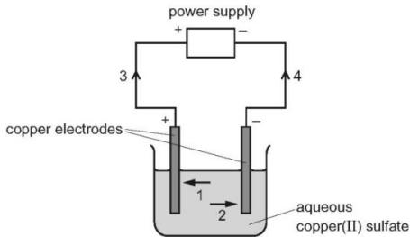
Which arrows indicate the movement of the copper ions in the electrolyte and of the electrons in the external circuit? （ ）
 | copper ions | electrons
A | 1 | 3
B | 1 | 4
C | 2 | 3
D | 2 | 4
5. The electrolysis of aqueous copper(II) sulfate, using inert electrodes, is shown.
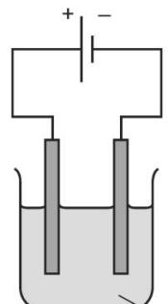
aqueous copper(II) sulfate
Which statement about a reaction at an electrode is correct? （ ）
A Copper ions gain electrons at the negative electrode.
B Copper ions gain electrons at the positive electrode.
C Hydrogen ions gain electrons at the negative electrode.
D Hydrogen ions gain electrons at the positive electrode.

2. 预测电解时的反应及其物质变化(不同的电极材料)
1. What are the electrode products when molten silver iodide is electrolysed between inert electrodes?（ ）
 | cathode | anode
A | hydrogen | iodine
B | iodine | silver
C | silver | iodine
D | silver | oxygen

2. What are the ionic half- equations for the electrode reactions during the electrolysis of concentrated aqueous sodium chloride?（ ）
 | anode | cathode
A | Cl₂+ 2e⁻→ 2Cl⁻ | H₂→ 2H⁺ + 2e−
B | 2Cl⁻→ Cl₂+ 2e− | 2H⁺ + 2e−→ H₂
C | H2→ 2H⁺ + 2e− | Cl₂+ 2e−→ 2Cl−
D | 2H⁺ + 2e−→ H2 | 2Cl−→ Cl₂ + 2e−

3. Electrolysis of copper(II) sulfate can be done using either carbon electrodes or copper electrodes.
Which statement describes what happens at the positive electrode?（ ）
A Copper is deposited if the electrode is made from carbon.
B Copper is deposited if the electrode is made from copper.
C Oxygen gas is produced if the electrode is made from carbon.
D Oxygen gas is produced if the electrode is made from copper.

4. Concentrated aqueous copper(II) chloride is electrolysed using copper electrodes as shown.
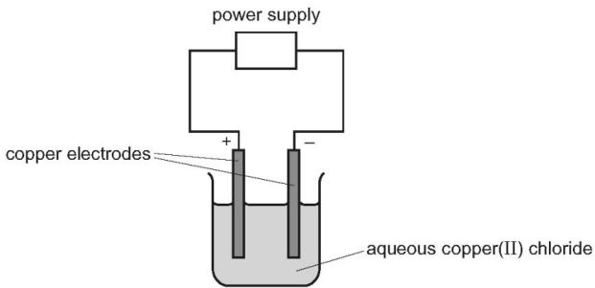
What happens to the mass of each electrode during this process? （ ）
 | positive electrode | negative electrode
A | decreases | decreases
B | decreases | increases
C | increases | decreases
D | increases | increases

5. The diagram shows a method used to copper- plate a pan
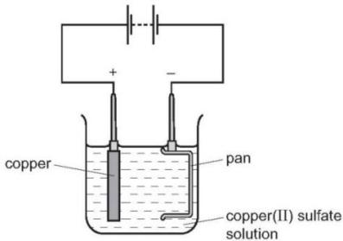
Which equation represents the reaction at the cathode? （ ）
A $Cu^{2+}+2e^{−}→Cu$
B $2H^{+}+2e^{−}→H_{2}$
C $40H^{−}→O_{2}+2H_{2}O+4e^{−}$
D ${20}^{2−}→O_{2}+4e^{−}$

3. 电镀的原理和装置的作用
1. Which apparatus could be used to electroplate an iron nail with copper?（ ）
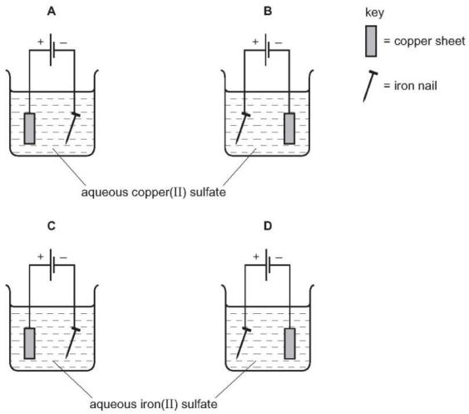
2. Winston Churchill, a British Prime Minister, had his false teeth electroplated with gold.
The teeth were coated with a thin layer of carbon and were then placed in the apparatus shown.
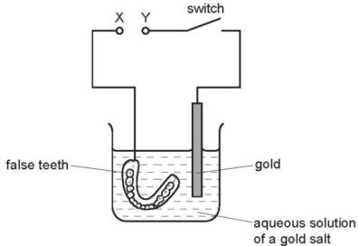
Which row is correct? （ ）
 | terminal X is | the carbon powder could be
A | negative | diamond
B | negative | graphite
C | positive | diamond
D | positive | graphite

3. The diagram shows an electrolysis experiment using metals X and Y as electrodes.
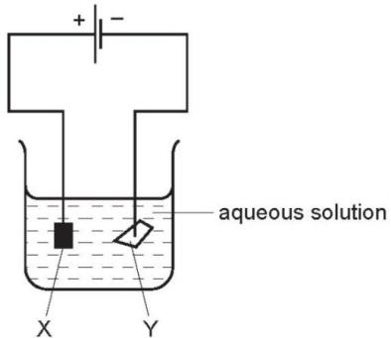
One of the metals becomes coated with copper.
Which metal becomes coated and which aqueous solution is used? （ ）
 | metal | aqueous solution
A | X | CrCl₃
B | X | CuCl₂
C | Y | CrCl₃
D | Y | CuCl₂

4.Which metal could not be used for electroplating by using an aqueous solution? （ ）
A chromium B copper C silver D sodium

5. An object is electroplated with silver using an aqueous silver salt as the electrolyte.
Which set of conditions is used?（ ）
 | the object to be electroplated is the | the other electrode is made from
A | anode | carbon
B | anode | silver
C | cathode | carbon
D | cathode | silver

6. The diagram shows the electroplating of a steel object.
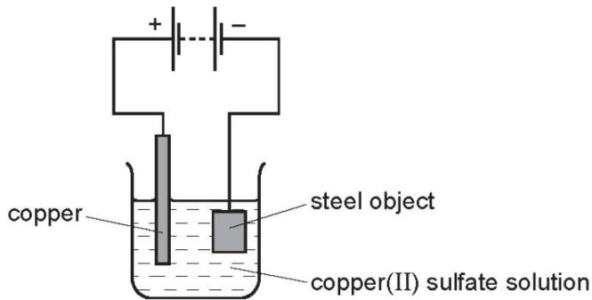
A student made the following statements.
1 The object turns a reddish- brown colour.
2 The copper sulfate solution changes to a paler blue colour.
3 The copper electrode becomes smaller.
Which statements are correct? （ ）
A 1, 2 and 3 B 1 and 2 only C 1 and 3 only D 2 and 3 only

4. 氢燃料电池的原理
1. Which statement about the hydrogen fuel cell is not correct?（ ）
A Chemical energy is converted into electrical energy.
B Hydrogen is oxidised.
C The reaction that takes place is endothermic.
D Water is the only product.

2. Fuel cells are used as energy sources in cars.
Which row gives a fuel used in a fuel cell and the products formed?（ ）
 | fuel in a fuel cell | products formed
A | hydrogen | carbon dioxide and water
B | hydrogen | water only
C | petrol | carbon dioxide and water
D | petrol | water only

3. Which statement about a fuel cell in a car is correct?（ ）
A The fuel cell produces heat, which powers the car.
B The fuel cell is supplied with hydrogen directly from the air.
C The only emission from a fuel cell is nitrogen gas, which is non- polluting.
D The fuel cell produces electricity, which powers an electric motor.

4. Which statements about hydrogen fuel cells are correct?（ ）
1 Water is formed as the only waste product.
2 Both water and carbon dioxide are formed as waste products.
3 The overall reaction is $2H_{2}+O_{2}→2H_{2}O$
4 The overall reaction is endothermic.
A 1 and 3 B 1 and 4 C 2 and 3 D 2 and 4

